SIMATS ENGINEERING (SAVEETHA SCHOOL OF ENGINEERING)
Department of Computer Science and Engineering
ASSESSMENT TOOL 3 – DEBUGGING & OPTIMISATION TASK
Course Code: | CSA0621 | Course Title: | Design and Analysis of Algorithms
CO Assessed: | CO2 – Manipulation (BL1, BL2, BL3) | Assessment: | Assessment Tool 3 – Debugging & Optimisation Task
Weightage: | 10% of CIA | Total Marks: | 100
CO2 Statement: | Apply Brute Force technique to solve sorting, searching, Closest-Pair and Convex-Hull problems (BL1, BL2, BL3)
Student Name: | RITHIKA J | Reg. No.: | 192524201
Section / Batch: | AIDS/25 | Date: | 06/08/26

Instructions to Students
• Answer ALL debugging and optimisation tasks. Total Marks: 100.
• Carefully analyze the given program/code segment before identifying errors.
• Clearly identify logical, syntactical, and performance-related issues in the code.
• Apply systematic debugging techniques to correct the errors effectively.
• Optimize the given solution by improving efficiency, reducing unnecessary computations, or enhancing time complexity wherever possible.
• Provide proper justification for all corrections and optimization decisions.
• Write clean, structured, and well-documented code with appropriate comments.
• Maintain clarity, logical reasoning, and technical accuracy throughout the solution.

Question Type | Focus Area | Questions | Marks
Debugging & Optimisation Task | Identify errors, debug programs, and optimize algorithm efficiency using appropriate techniques | Q1 - Q2 | 100 (2 × 50)
GRAND TOTAL: |  | 100 Marks

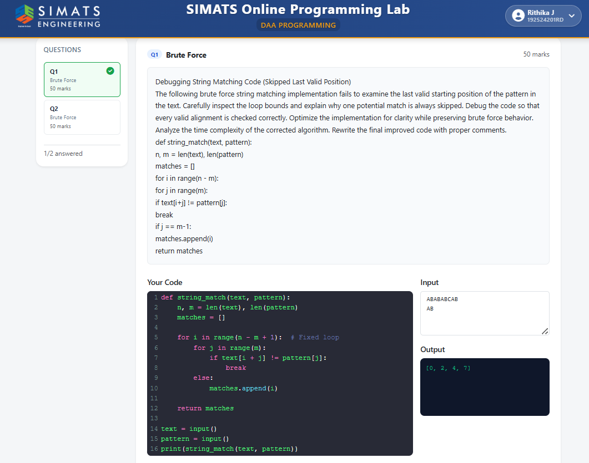

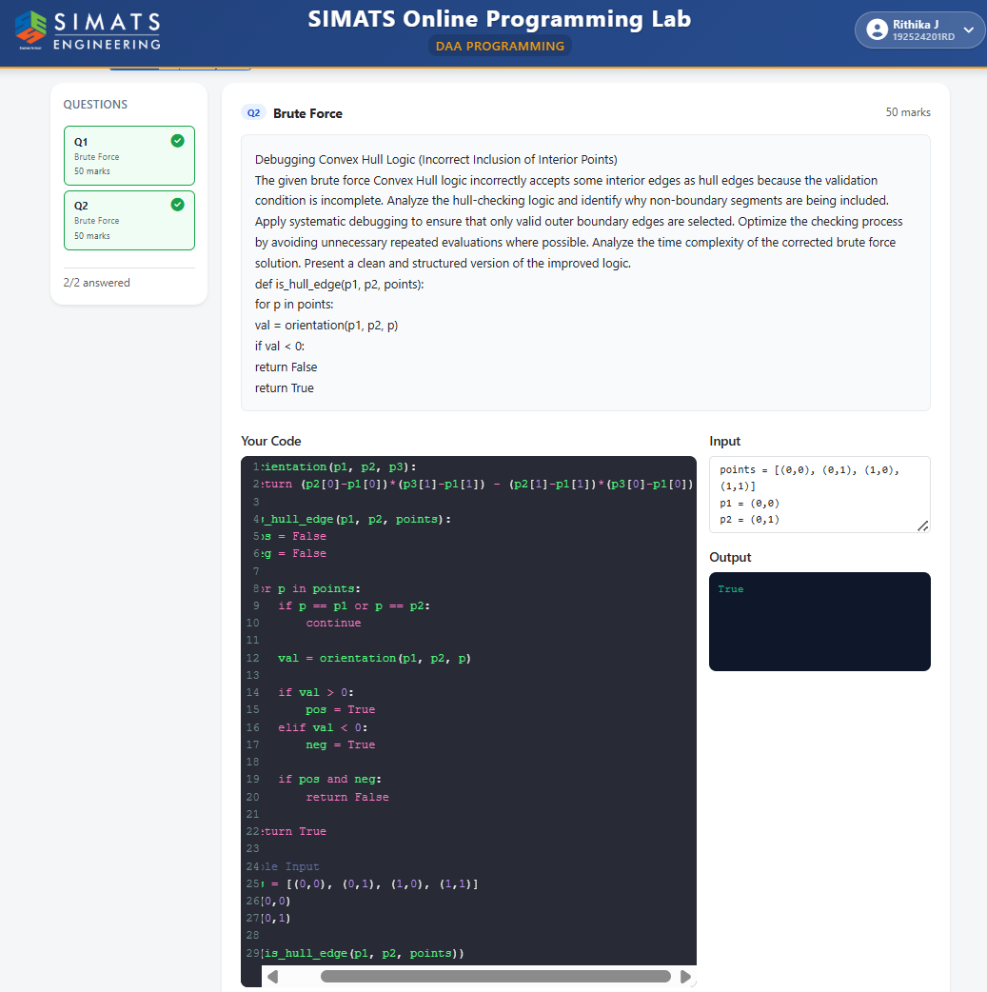
Code of Conduct
I RITHIKA J (192524201) certify that this submission is my original work and that I have adhered to the guidelines specified for this assessment. I understand that any violation of academic integrity rules will result in disciplinary action.
Signature of the Student:
RUBRICS FOR CALCULATION
Criteria | Wt. | Level 4 – Exemplary | Level 3 – Proficient | Level 2 – Developing | Level 1 – Beginning
Problem Identification | 20% | Accurately identifies all errors and root causes with clear understanding | Identifies most errors with minor gaps | Identifies some errors but misses key issues | Unable to identify errors correctly
Debugging | 25% | Applies systematic debugging techniques effectively to resolve issues | Uses appropriate debugging methods with minor errors | Limited debugging approach; requires guidance | Unable to debug or resolve issues
Optimization | 20% | Optimizes code by significantly improving time complexity using efficient algorithms | Improves time complexity with minor gaps in efficiency | Limited improvement in time complexity | No improvement; inefficient approach retained
Analysis | 20% | Demonstrates strong logical reasoning and clear justification of solutions | Shows reasonable analysis with some justification | Limited analysis; weak reasoning | No analytical reasoning demonstrated
Code Quality | 15% | Produces clean, well-structured code with proper comments and documentation | Code is mostly clear with minor documentation gaps | Code lacks structure and proper documentation | Poorly written code with no documentation

Marks Evaluation:
Question No. | Problem Identification (20%) | Debugging (25%) | Optimization (20%) | Analysis (20%) | Code Quality (15%) | Total Marks (Each – 50)
Q1
Q2
Overall Total (100)

Faculty In-charge | Course Coordinator | Head of Department
Signature: _______________ | Signature: _______________ | Signature: _______________
Date: ___________________ | Date: ___________________ | Date: ___________________

